Health is a state of complete harmony of the body, mind and spirit. When one is free from physical disabilities and mental distraction, the gates of the soul open

7 Minutes Workout

Android Application

Mr. Rahul K. Devkate

Mr. Umesh V. Madane

Mr. Swapnil B. More

Mr. Shubham Gorakh Shende

Mr. Dnyaneshwar S. Lohar

**Project Report on**

**“7 Minutes Workout Android Application”**

**Submitted by:**

**Mr. RAHUL K. DEVKATE (PRN:** **2019032500209617)**

**Mr. UMESH V. MADANE (PRN:** **2019032500208614)**

**Mr. SWAPNIL B. MORE (PRN:** **2019032500208711)**

**Mr. SHUBHAM G. SHENDE (PRN:2016032500265982)**

**Mr. DNYANESHWAR S. LOHAR (PRN:** **2019032500208564)**

**UNDER THE GUIDANCE OF**

**Mr. S. C. Salotagi**

**in partial fulfilment for the award of the degree**

**of**

**BACHELOR OF TECHNOLOGY**

**IN**

**DEPARTMENT OF COMPUTER SCIENCE AND ENGINEERING**

**At**



**SHRI VITHAL EDUCATION and RESEARCH INSTITUTES’s, COLLEGE OF ENGINEERING, PANDHARPUR**

**AFFILIATED TO PUNYASHLOK AHILYADEVI HOLKAR SOLAPUR UNIVERSITY, SOLAPUR**

**2021-2022**



**SVERI’s COLLEGE OF ENGINEERING,**

**PANDHARPUR**

**CERTIFICATE**

This is to certify that the project report entitled **“7 Minutes Workout Android Application”** is submitted for partial fulfilment of Bachelor Degree in Computer Science and Engineering as per requirement of Punyashlok Ahilyadevi Holkar Solapur University, Solapur for the academic year 2021-2022.

**Acknowledgement**

We are pleased to acknowledge **Dr. A. S. Budhewar** (HOD CSE) madam for his valuable guidance during the course of this project work. We extend our sincere thanks to **Mr. P. D. Mane** sir who continuously helped us throughout the project and without his guidance, this project would have been an uphill task.

We are also grateful to other members of the CSE faculty members and technical staff who cooperated with us regarding some issues.

**Signature**

**(Mr. Rahul K. Devkate Sign. ................... )**

**(Mr. Umesh V. Madane Sign. ................... )**

**(Mr. Swapnil B. More Sign. ................... )**

**(Mr. Shubham Gorakh Shende Sign. ................... )**

**(Mr. Dnyaneshwar S. Lohar Sign. ................... )**

**SYNOPSIS**

**1.Synopsis of Project Work**

1. **Relevance:**

We often see around that people are not taking care of their health. Once health is as important as any materialistic thing around them. As I am a computer Engineer, I personally experienced the need of health-related app to be once crucial guides in day-to-day life. The goal of health apps is to make the experience of healthcare more efficient and satisfying for all stakeholders involved. Health apps are ultimately judged by their value to the healthcare system; their ability to improve the patient experience and patient outcomes as well as reduce the costs of care.

1. **Present theories and practices:**

**1.MyFitnessPal**

MyFitnessPal will calculate the number of calories you've consumed from food and burned from exercise and let you know how many calories you have left to eat for the day. If you stick within your calorie limits, you should achieve the weight loss (or gain) you're looking for.

**2.Headspace**

Headspace is a mindfulness app with an easy-to-use interface that takes the seriousness and intimidation out of meditation. According to TechCrunch, Headspace is one of the most frequently downloaded mindfulness apps in the world, only second after Calm, garnering millions of downloads.

**3.Fitplan**

Fitplan is a mobile application that provides on-demand video workout sessions. Consumers can sign up for a subscription (monthly or annual) or utilize their library of free single day workouts. All the workouts are formulated by dozens of fitness coaches.

1. **Proposed work:**

**1. Scope of project:**

1. The scope of 7-minute workout app is to provide some exercise to users
2. User can test himself/herself on BMI index
3. User can see the history of his/her workout

**2. Objectives:**

a. The main objective of this app to make user to do regular exercise

b.Storing user Details of exercises

c. observing if the exercises are consistent or not

**3. Phase wise Proposed Work:**

**Phase 1**

1. Finalizing Project Topic
2. Requirement Collection
3. Design the Modules

**Phase 2**

1. Coding
2. Testing and Validation

**4. Approximate expenditure:**

a. Developer account: - Rs 2000/-

**Contents**

***Title Page i***

***Certificate ii***

***Acknowledgement iii***

***Synopsis iv***

***Table of Contents vi***

**1. INTRODUCTION**

* 1. Introduction…………………………………………………………………….1
  2. Problems……………………………………………………………………….1
  3. Objective……………………………………………………………………….2
  4. User friendly……………………………………………………………….......2

**2 LITERATURE SURVEY**

2.1 Existing System …...…………………………………………………………3

2.2 The Importance of Exercise ………………………………………………….4

2.3 Proposed System ……………………………………………………………. 6

2.4 Advantageous of Proposed System …………………………………………. 7

**3 SYSTEM ANALYSIS AND DESIGN** 8

3.1 Project structure……….……………………………………………………..8

3.2 Description of Features and The Approach…………………………………12

3.3 ER Diagrams…….………………………………………………………….16

**4 METHODOLOGY/ TECHNIQUES USED** 18

4.1 Development tools…………………………………………………………..18

4.2 Developer workflow……………………………………………………..….22

**5 EXPERIMENTAL RESULTS / OUTPUTS 25**

**6 CONCLUSIONS AND FUTURE SCOPE 29**

**References 31**

**Chapter 1**

**INTRODUCTION**

* 1. **Introduction**

You might think your smartphone is only for making calls, texting, or scrolling through social media. But this pocket-sized device is also an excellent tool for tracking, managing, and staying on top of your fitness goal. Fitness apps are specialized programs you can download on a phone, tablet, or other electronic devices. Some apps work great with the free version while others require shelling out a few dollars each month to access premium features. But they all aim to provide guidance, maintains, and accountability.

We looked at fitness apps that offer a free version and a paid subscription or in-app purchase option. In general, the best fitness apps have a flexible subscription, come with multiple workout routines, and give you the ability to customize a program specific to your needs. Here are our top picks for the best fitness apps

* 1. **Problems**

Problems which may cause this app not to get attention in market:

1.we are amateurs so our app is very simple, we are not able to add complex features which other apps provide on play store.

2. You Won’t Exercise Yourself Thin, it requires high determination for one to exercise every day, so an app won’t be able to make you exercise every day

3. Most fitness apps and activity trackers operate from the pervasive myth that all calories affect the body in the same way. They don’t!

4. People who dislike physical exercise elicit a psychological phenomenon called “moral licensing,” which makes them more likely to over consume to reward their hard work. Without a base of proper nutrition, we can’t exercise ourselves thin.

**1.3 Objectives**

The main objective of this app is to provide some exercise to user to practise it every day, stepwise and live a healthier life

* 1. **User Friendly:**

This app is very user friendly as it has only three buttons at its interface. And it does not have any complex feature which makes it very easy to use

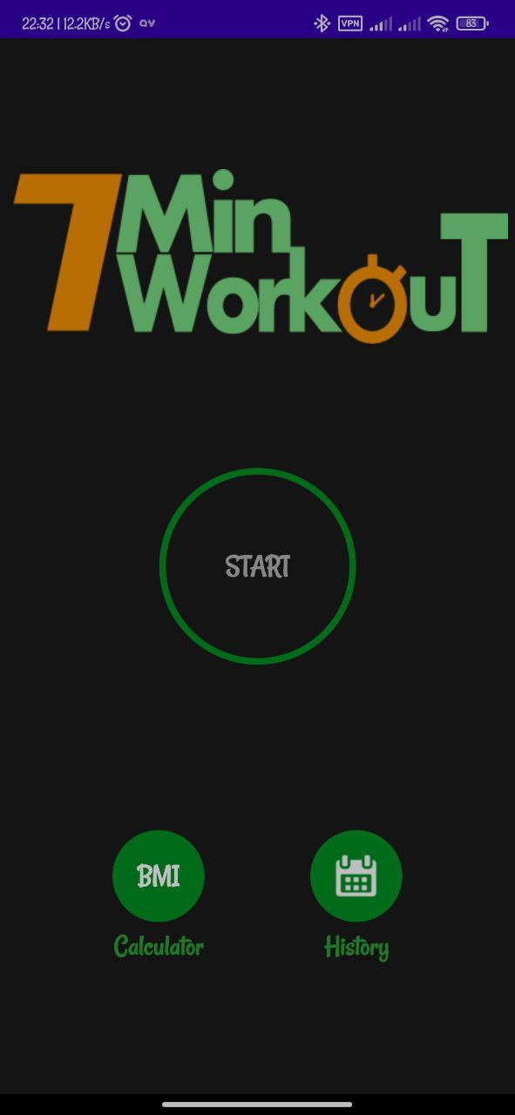

**Chapter 2**

**LITERATURE SURVEY**

**2.1 Existing System**

There are many different android applications in market which helped in our projects and gave lots of new ideas. We studied some benefits of exercises based on that we have selected some exercises which can be exercised daily by all age group to stay fit. Currently most popular apps are discussed as follows:

1. **MyFitnessPal**

MyFitnessPal is a smartphone app and website that tracks diet and exercise. It offers auto-renewing systems, according to Apple. The app uses gamification elements to encourage adherence to exercise and diet goals. To track nutrients, users can either scan the barcodes of various food items or manually find them in the app's large pre-existing database. MyFitnessPal has access to 14 million food nutrients. These metrics can be used to track exercise and calories.

1. **Headspace**

Headspace is a mindfulness app with an easy-to-use interface that takes the seriousness and intimidation out of meditation.

According to TechCrunch, Headspace is one of the most frequently downloaded mindfulness apps in the world, only second after Calm, garnering millions of downloads.

1. **Fit plan**

Fitplan is a mobile application that provides on-demand video workout sessions. Consumers can sign up for a subscription (monthly or annual) or utilize their library of free single day workouts. All the workouts are formulated by dozens of fitness coaches, including the influencers on Instagram.

**2.2 The Importance of Exercise**

Community centres, local YMCAs, health clubs, and other organizations offer age-appropriate exercise programs for children and adolescents led by experienced and knowledgeable instructors. In addition, home exercise videos geared toward children are available in stores and from Web sites.

For children and adolescents with medical conditions that may limit exercise or place them at higher risk for exercise-related complications, supervised exercise programs may be available at hospital-based wellness centres.

We all know that exercise is important in our daily lives, but we may not know why or what exercise can do for us.

It’s important to remember that we have evolved from nomadic ancestors who spent all their time moving around in search of food and shelter, travelling large distances on a daily basis. Our bodies are designed and have evolved to be regularly active.

In the same way that a sports car is designed to go fast, we are designed to move. If the sports car is taken out once a week for a 3-mile round trip through a town centre then it would probably develop engine problems fairly quickly.

Over time people too develop problems if they sit down all day at a desk or in front of the TV and minimise the amount of exercise they do.

**2.2.1 The Benefits of Exercise**

There are many benefits of regular exercise and maintaining fitness and these include:

• Exercise increases energy levels

• Exercise improves muscle strength

• Exercise can help you to maintain a healthy weight

• Exercise improves brain function

• Exercise is good for your heart

• Regular exercise lowers your risk of developing type 2 diabetes

• Exercise enhances your immune system

• Staying active reduces the likelihood of developing some degenerative bone diseases

• Exercise may help to reduce the risk of certain cancers

• Active people tend to sleep better

• Exercise improves your mood and gives you an improved sense of well-being

• Exercise can help prevent and treat mental illnesses like depression

• Keeping fit can reduce some of the effects of ageing

**2.3 Proposed System**

We proposed solution that we came up with, is an android application (7-minute workout app) which is inspired by above survey. Our application is very user friendly. As android apps are highly in use in mobiles, we thought doing this project in android would create impact on society. Why a Mobile Application? A Mobile Application is a set of software which is designed and developed in such a way that it can run on any mobile device, smart phone or tablet.

We created an application for people who have less time throughout the day for workout. That’s why create our application which will help to user to do exercise within 7 minutes. In our application provided some demos and steps of exercises and audio instruction which makes it easy to follow and user-friendly. After completion of all exercises, present time and date (exercise completion time) of that device is stored in database as Exercise history.

**2.4 Advantages of Proposed System**

* By using our application user will doing exercise in less time than other exercise application.
* Application available in play store, exercise have only names and their description, but in our application, we have name as well as tutorial of each exercise that’s why it is easier to do exercise for beginners.
* Application UI is simple and user friendly.
* In our application, we have notification sound that will notify you that time for your previous exercise is finished, now it is time to do next exercise.
* In our application we have history option i.e., you can check that how many times you do the workout and check your daily, weekly or monthly progress.
* In our application we have a BMI calculator also so that you can also calculate your Body Mass Index to check how many weights you have to loss or gain for healthy body.
* User can do exercise in within less than 10 minutes.

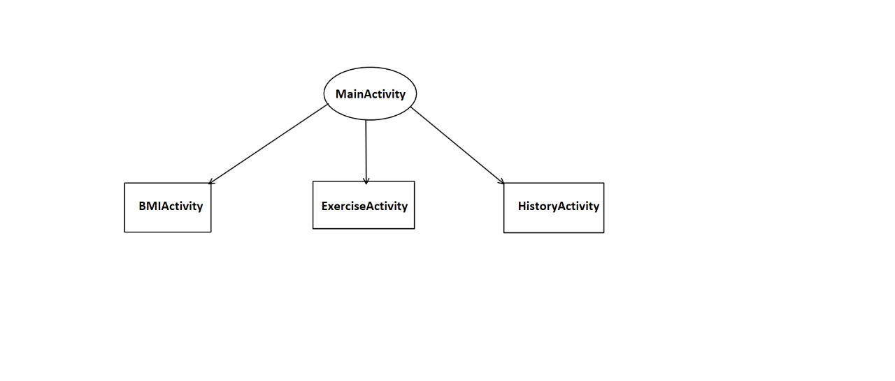

**Chapter 3**

**SYSTEM ANALYSIS AND DESIGN**

System analysis is the process of gathering and interpreting facts, diagnosing problems and using the information to recommend improvements on the system. System analysis is a problem-solving activity that requires intensive communication between the system users and system developers.

System analysis or study is an important phase of any system development process. The system is viewed as a whole, the inputs are identified and the system is subjected to close study to identify the problem areas. The solutions are given as a proposal. The proposal is reviewed on user request and suitable changes are made. This loop ends as soon as the user is satisfied with the proposal.

**3.1 Project structure**

Each project in Android Studio contains one or more modules with source code files and resource files. Types of modules include:

* Android app modules
* Library modules
* Google App Engine modules

By default, Android Studio displays your project files in the Android project view, this view is organized by modules to provide quick access to your project's key source files.

All the build files are visible at the top level under **Gradle Scripts** and each app module contains the following folders:

* **manifests**: Contains the AndroidManifest.xml file.
* **java**: Contains the Java source code files, including JUnit test code.
* **res**: Contains all non-code resources, such as XML layouts, UI strings, and bitmap images.

The Android project structure on disk differs from this flattened representation. To see the actual file structure of the project, select **Project** from the **Project** dropdown

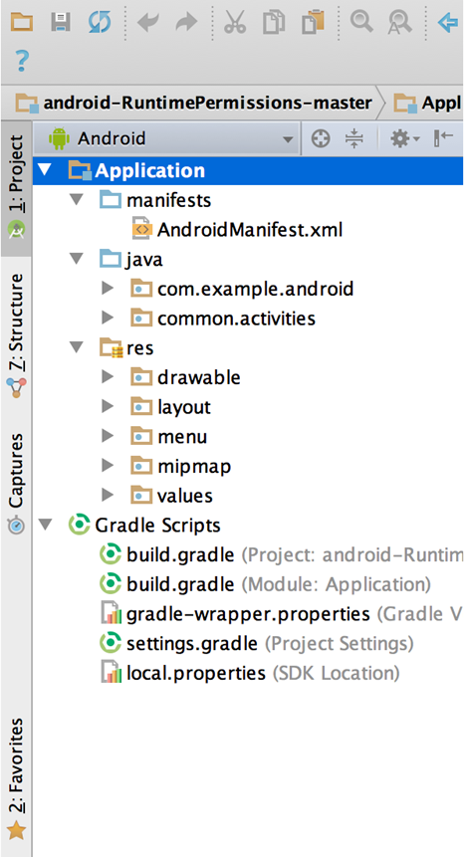

**Figure 1.** The project files in Android view.

**3.1.1 BMI (Body Mass Index)**

**Body mass index** (**BMI**) is a value derived from the mass (weight) and height of a person. The BMI is defined as the body mass divided by the square of the body height, and is expressed in units of (kg/m2), resulting from mass in kilograms and height in metres.

BMI is a measurement of a person's leanness or corpulence based on their height and weight, and is intended to quantify tissue mass. It is widely used as a general indicator of whether a person has a healthy body weight for their height.

**BMI, basic categories**

|  |  |
| --- | --- |
| Category | BMI range - kg/m2 |
| Severe Thinness | < 16 |
| Moderate Thinness | 16 - 17 |
| Mild Thinness | 17 – 18.5 |
| Normal | 18.5 - 25 |
| Overweight | 25 - 30 |
| Obese Class I | 30 - 35 |
| Obese Class II | 35 - 40 |
| Obese Class III | > 40 |

## **How is BMI calculated?**

|  |  |
| --- | --- |
| **Measurement Units** | **Formula and Calculation** |
| Kilograms and meters (or centimetres or inches) | Formula: weight (kg) / [height (m)]2  With the metric system, the formula for BMI is weight in kilograms divided by height in meters squared. Because height is commonly measured in centimetres, divide height in centimetres by 100 to obtain height in meters. |
| **Pounds and inches** | Formula: weight (lb) / [height (in)]2 x 703  Calculate BMI by dividing weight in pounds (lbs) by height in inches (in) squared and multiplying by a conversion factor of 703. |

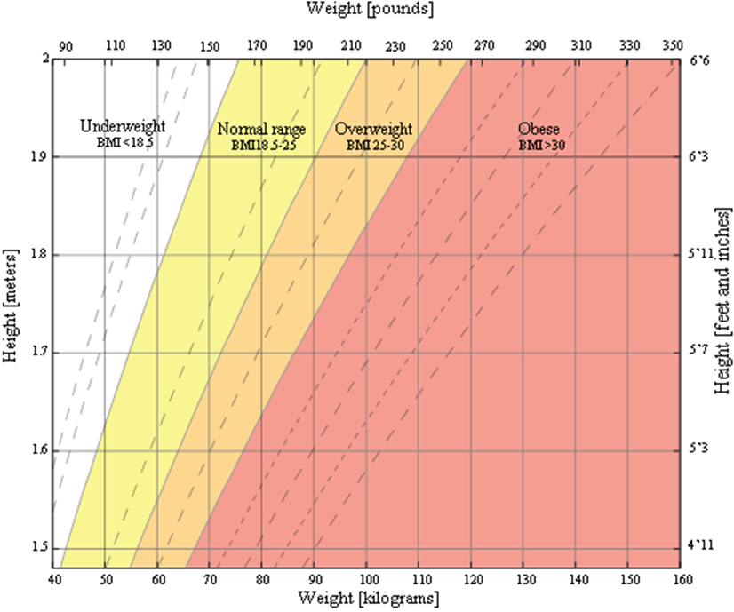

Figure: Chart showing body mass index (BMI) for a range of heights and weights in both metric and imperial.

**3.2 Description of Features and The Approach**

**1. Main Activity**

The main activity code is a Kotlin file **MainActivity.kt**. This is the actual application file which ultimately gets converted to an executable and runs your application.

The **activity_main.xml** is a layout file available in *res/layout* directory, that is referenced by your application when building its interface. Here we have *ImageView* is used on App Icon and *TextView* Icons, *TextViews* for Start, History and BMI indications. These *TextView* on click listen the next task to be performed. Adding a click event to launch the History Screen Activity from Main Activity. You can/will modify this file very frequently to change the layout of your application.

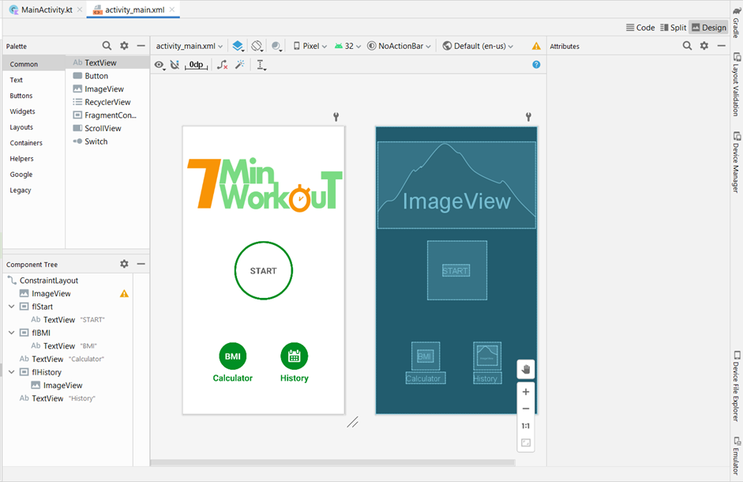

Main Activity Figure

**2. Exercise Activity**

**ExerciseActivity.kt** contains all the major code which drives this activity.

* Performing the steps to show the custom dialog for back button confirmation while the exercise is going on.
* Calling the function where we have bound the adapter to recycler view to show the data in the UI.
* Plays the sound at the beginning of starting the exercise and while telling the name of the exercise.
* Function is used to speak the text that we pass to it.
* Function is used to set up the recycler view to UI and assigning the Layout Manager and Adapter Class is attached to it
* Function is used to launch the custom confirmation dialog.

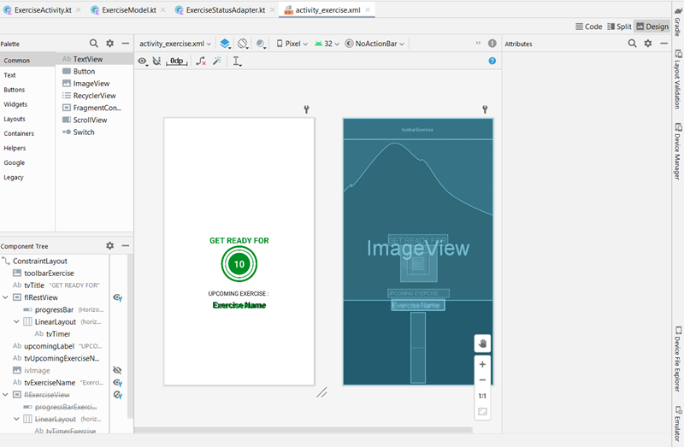

Layout for Exercise Activity is shown in the figure above and in file activity_exercise.xml. Exercise Related Activities are arranged in the three Kotlin files.

**3. BMI Activity**

## BMIActivity.kt, it allows us to switch between the tabs as per the user requirement. One tab the BMI is calculated using the input provided by the user in SI units i.e., weight in Kg and height in cm which is converted to the meters at the time of using formula and another tab input height in feet inches. BMI here are calculated as per the US system.

## 

Figure: BMI Calculator Layout

1. **Finish Activity**

**FinishActivity** is the last activity after exercise. **FinishActivity.kt**, we have a Function is used to insert the current system date in the SQLite database. We have taken an instance of Date Formatter as it will format our selected date in the format which we pass it as a parameter and Locale. The format is dd MMM YYYY HH:MM: SS.

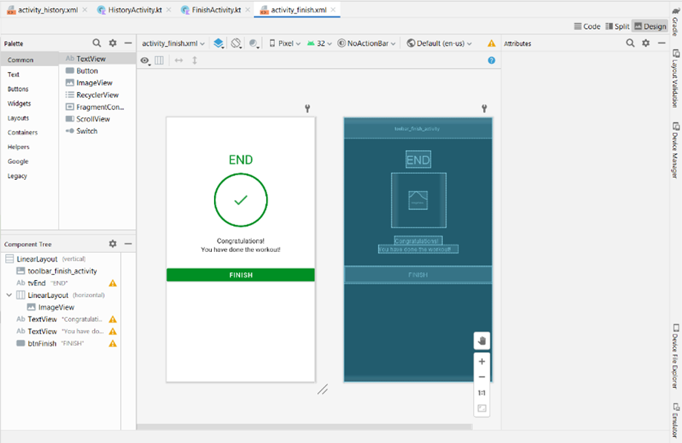

Figure: Finish Activity Layout

**3.3 ER Diagrams**

* **Flow of whole application**

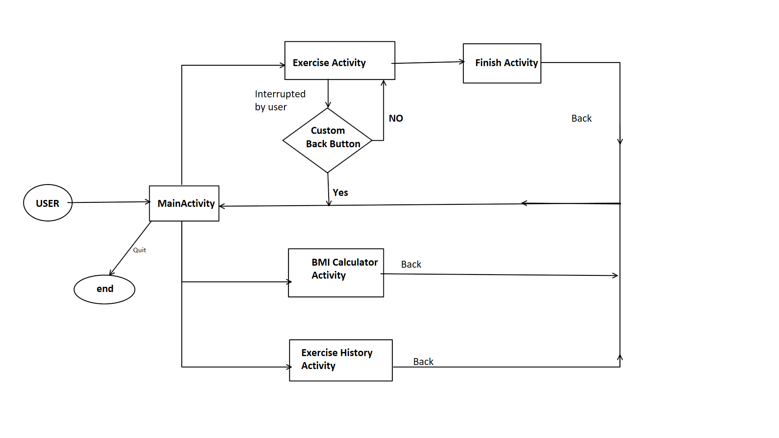

* **Main activity**

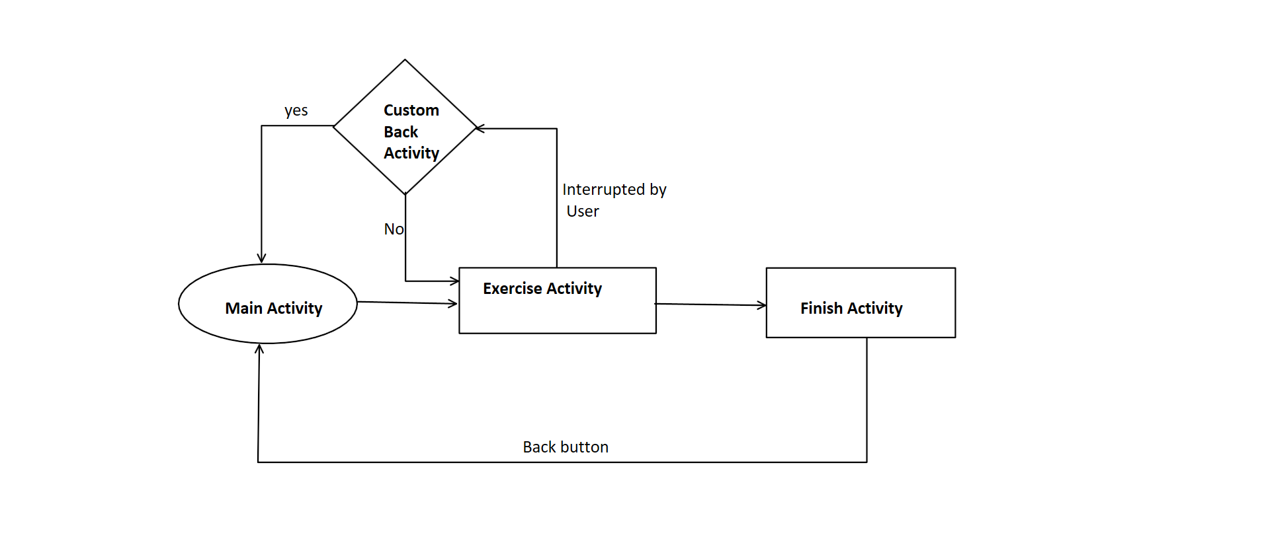

* **UI interface**

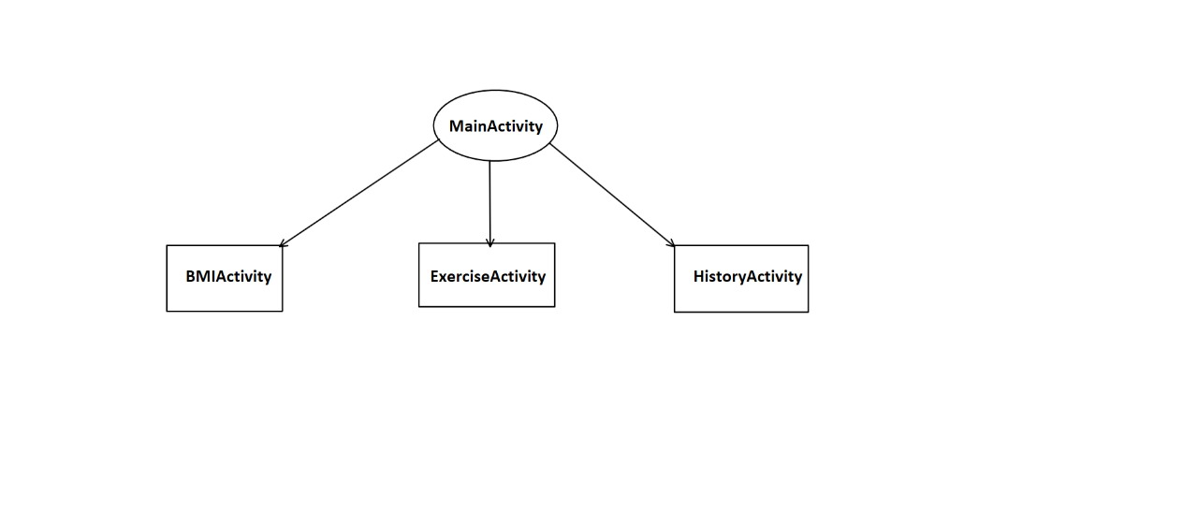

* **Data flow diagram**

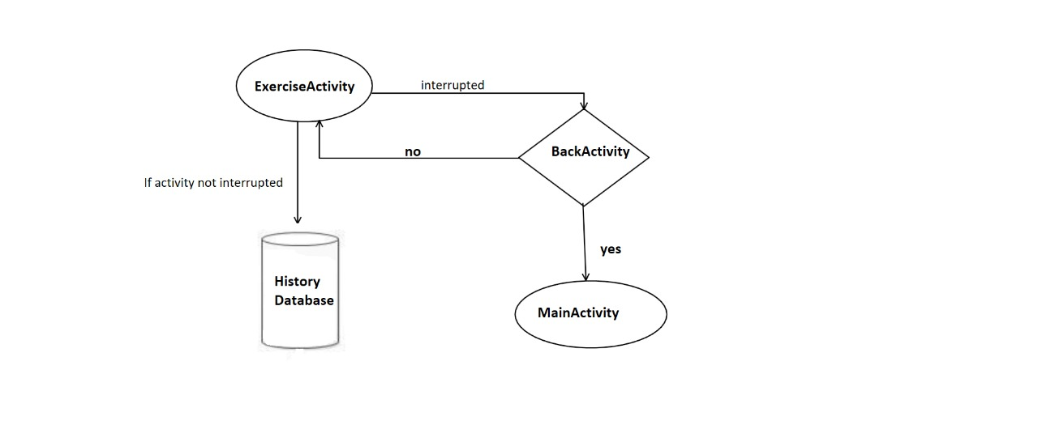

**Chapter 4**

**METHODOLOGY/ TECHNIQUES USED**

**4.1 Development Tools**

**4.1.1 Android Studio**

The development of Android applications is done using the Android Software Development Kit (SDK). This SDK comes with all the necessary development tools needed, including all the relevant libraries, a debugger and an Android emulator. The main platforms which are currently supported for development or Android are any modern desktop Linux distribution, Windows XP or later, and Mac OS X 10.5.8 or later.

Other main tools include Android SDK, ADB, and Gradle Build.

**4.1.2 Android Software Development Kit (SDK):**

One of the main tools used in developing android applications, as it packages many core features into one SDK and it can be used in the application easily. This helps us to avoid writing lot of code, and building applications faster.

**4.1.3 Gradle Build:**

Gradle Scripts are the recent feature that is added to Android Studio. It is basically an automated build system which is used to automate the various phases involved in designing an application that includes design, development, test, debug, and publish. We need to configure the project and modules by mentioning all the supported jar files, SDK’s, version name, level, compiled SDK version, build tools version. to ensure that the developed app is compatible with the testing device/emulator. Gradle is also similar to Ant and Maven which helps in maintaining java projects (repositories).

Android Studio uses Gradle as the foundation of the build system, with more Android-specific capabilities provided by the Android Plugin for Gradle. This build system runs as an integrated tool from the Android Studio menu, and independently from the command line. You can use the features of the build system to do the following:

* Customize, configure, and extend the build process.
* Create multiple APKs for your app, with different features using the same project and modules.
* Reuse code and resources across source sets.

By employing the flexibility of Gradle, you can achieve all of this without modifying your app's core source files. Android Studio build files are named *build.gradle*.

**4.1.4 Android Device Monitor**

If we want to access all the hidden files that are generated when we run the application, we can use the monitor. We can select any project and explore the files that are related to that project. But, as they are hidden files, we need root permissions to access them. Suppose, if we run the app in device, we need to root the device and run commands in **adb** shell to get permissions.

**4.1.5 AVD Manager**

It is used to create virtual devices of any desired API level to support higher level SDK’s in case our device does not support. Using emulators to test the application is difficult as it might be little slower when compared to real device.

**Perform common actions in the emulator**

To perform common actions with the emulator, use the panel on the right side, as described in table 2.

You can use keyboard shortcuts to perform many common actions in the emulator.

**Table 2.** Common actions in the emulator

|  |  |
| --- | --- |
| **Feature** | **Description** |
| Close Close icon | Close the emulator. |
| Minimize Minimize icon | Minimize the emulator window. |
| Resize | Resize the emulator as you would any other operating system window. The emulator maintains an aspect ratio appropriate for your device. |
| Power Power icon | Click to turn the screen on or off. Click and hold to turn the device on or off. |
| Volume up Volume Up icon | Click to view a slider control and turn the volume up. Click again to turn it up more, or use the slider control to change the volume. |
| Volume down Volume Down icon | Click to view a slider control and turn the volume down. Click again to turn it down more, or use the slider control to change the volume. |
| Rotate left Rotate Left icon | Rotate the device 90 degrees counterclockwise. |
| Rotate right Rotate Right icon | Rotate the device 90 degrees clockwise. |
| Take screenshot Take Screenshot icon | Click to take a screenshot of the device. |
| Enter zoom mode Enter Zoom Mode icon | Click so the cursor changes to the zoom icon. To exit zoom mode, click the button again.  Zoom in and out in zoom mode:   * Left-click the screen to zoom in by 25%, up to a maximum of about twice the screen resolution of the virtual device. * Right-click to zoom out. * Left-click and drag to select a box-shaped area to zoom in on. * Right-click and drag a selection box to reset to default zoom.   To pan in zoom mode, hold Control (Command on Mac) while pressing the arrow keys on the keyboard.  To tap the device screen in zoom mode, Control-click (Command-click on Mac). |
| Back  Back icon | Return to the previous screen, or close a dialog box, an options menu, the Notifications panel, or the onscreen keyboard. |
| Home Home icon | Return to the Home screen. |
| Overview Overview icon  (Recent Apps) | Tap to open a list of thumbnail images of apps you’ve worked with recently. To open an app, tap it. To remove a thumbnail from the list, swipe it left or right. This button isn't supported for Wear OS. |
| Fold Fold icon | For foldable devices, fold the device to display its smaller screen configuration. |
| Unfold Unfold icon | For foldable devices, unfold the device to display its larger screen configuration. |
| Menu | Press Control+M (Command+M on Mac) to simulate the Menu button. |
| More More icon | Click to access other features and settings, described in the next table. |

**4.1.6 SQLite Database:**

Android also supports inbuilt database which is Android SQLite to develop any small applications and perform any CRUD (Create, Update, and Delete) operations. As it is not flexible enough to support substantial number of data, for complex applications we are using other external databases.

# **4.2** **Developer workflow**

The workflow to develop an app for Android is conceptually the same as other app platforms. However, to efficiently build a well-designed app for Android, you need some specialized tools. The following list provides an overview of the process to build an Android app and includes links to some Android Studio tools you should use during each phase of development.

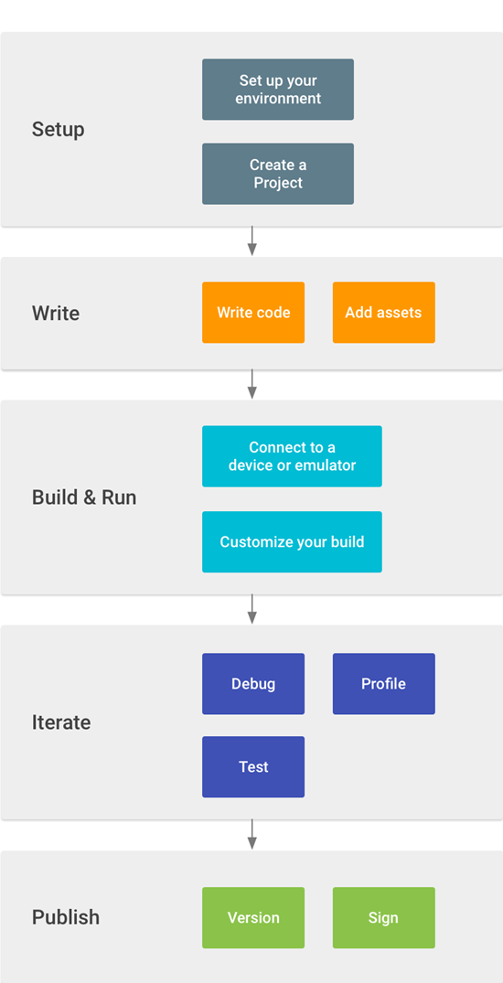

1.Set up your workspace

This is the phase you probably already finished: Install Android Studio and create a project.

2.Write your app

Now you can get to work. Android Studio includes a variety of tools and intelligence to help you work faster, write quality code, design a UI, and create resources for different device types.

3.Build and run

During this phase, you build your project into a debuggable APK package that you can install and run on the emulator or an Android-powered device. For more information about how to run your code, see Build and run your app.

You can also begin customizing your build and shrink your code and resources to make your app smaller. For an introduction to customizing your build, see Configure your build.

4.Debug, profile, and test

This is the iterative phase in which you continue writing your app but with a focus on eliminating bugs and optimizing app performance. Of course, creating tests will help you in those endeavors. For information about basic debugging tasks, read Debug your app and Write and view logs. To view and analyze various performance metrics such as memory usage, network traffic, CPU impact, and more, see Performance profiling tools.

5.Publish

When you're ready to release your app to users, there are just a few more things to consider, such as versioning your app, building an Android App Bundle, and signing it with a key. For more information, see the Publish your app.

**Chapter 5**

**EXPERIMENTAL RESULTS / OUTPUTS**

***• Main interface: -***

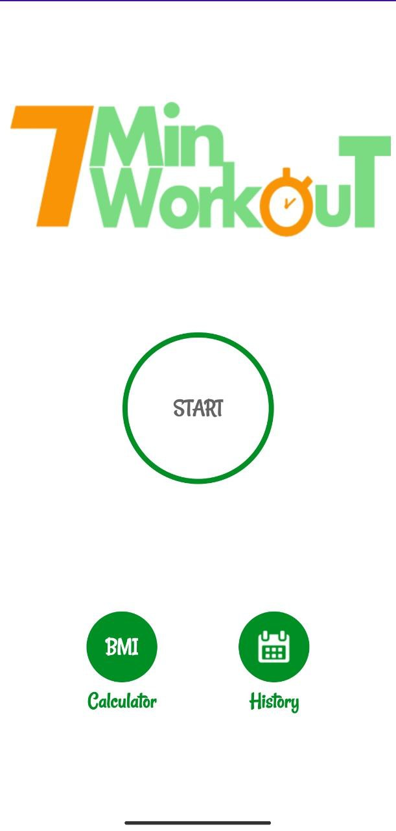

This the output of main activity. Which displays three buttons (START

CALCULATER, HISTORY) and an icon 7min workout. user will click on start button which will take user to 12 exercises for some specific time frames.

* ***BMI calculator:***

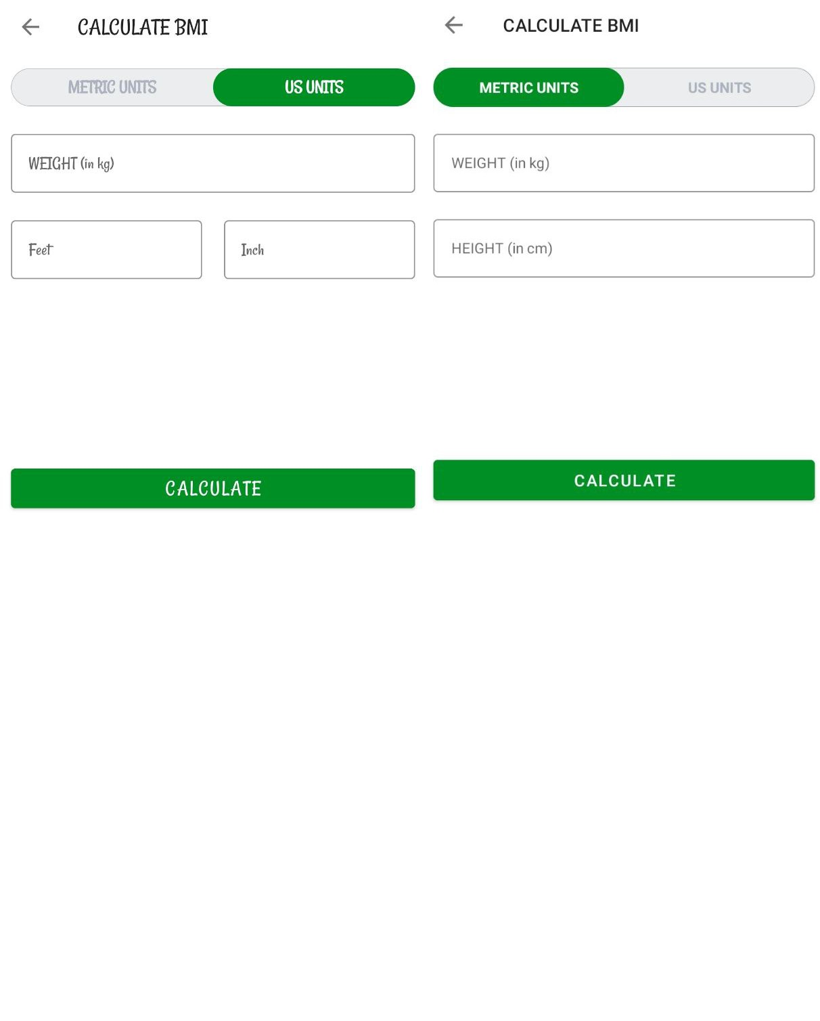

This is the second button which lets you calculate BMI of person.

Which instruct user if a person is (underweight, overweight, obese)

* ***History:***

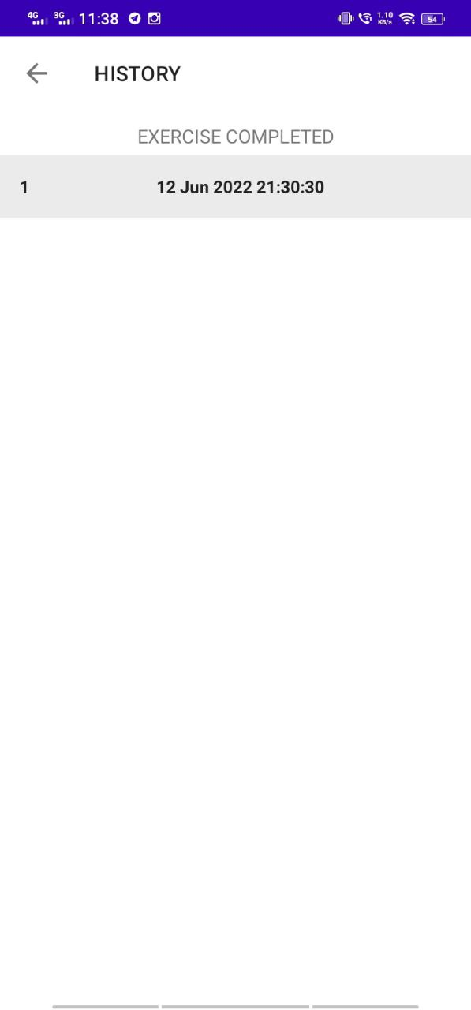

This is an history button which shows your history of workout.

* ***Exercises / finish interface***

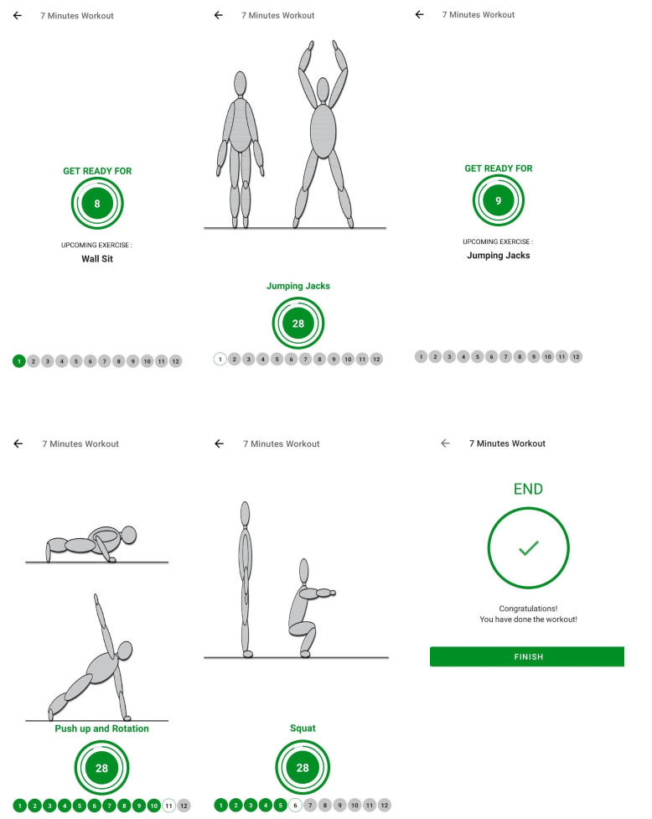

There are 12 exercises with timer which one should follow every day to stay fit.

**Chapter 6**

**CONCLUSIONS AND FUTURE SCOPE**

**Conclusion:**

The project titled 7-minute workout app is an android-based application that enables the user to keep an eye on their fitness regime. The project has been completed successfully with maximum satisfaction. The constraints are met and overcome successfully. The system is designed like it was decided in the design phase. The project gives a good idea on developing a user-friendly application satisfying the user. The system is very flexible and versatile. This application has a user-friendly screen that enables the user to use it without any inconvenience.

This project is more informative and more helpful for understanding the concept of android app development. This project is only a small and easy one but it is enough to implement my concept. we can further try much harder to make a much more efficient and useful app that can benefit others

**FUTURE SCOPE:**

As we are in learning phase, we tend to add less features as time progresses, we learn android, and other important skills then We are definitely going to work on this project and add some more features.

Features to be added are as follows:

1.Send alert message to the users.

2.add some gym music and meditative feature

3.add some diet plan according to user BMI and meal time

4.use some features of fitness watches